Create new folder and open it in vscode
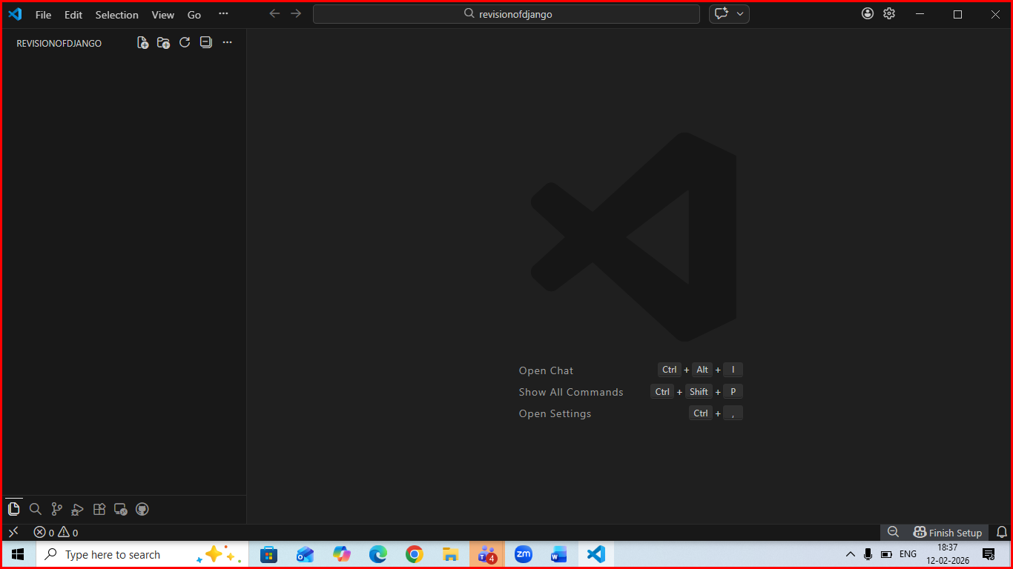
Open integrated terminal and create virtual env like this :
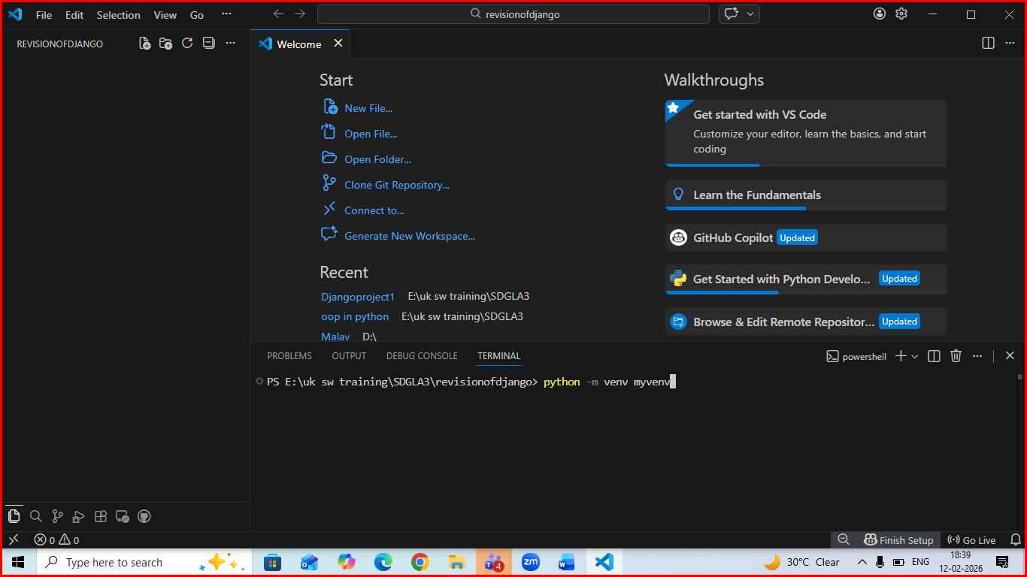
Activate virtual environment using command :
For windows : myvenv/Scripts/activate or myvenv/bin/activate
For mac :source myvenv/Scripts/activate
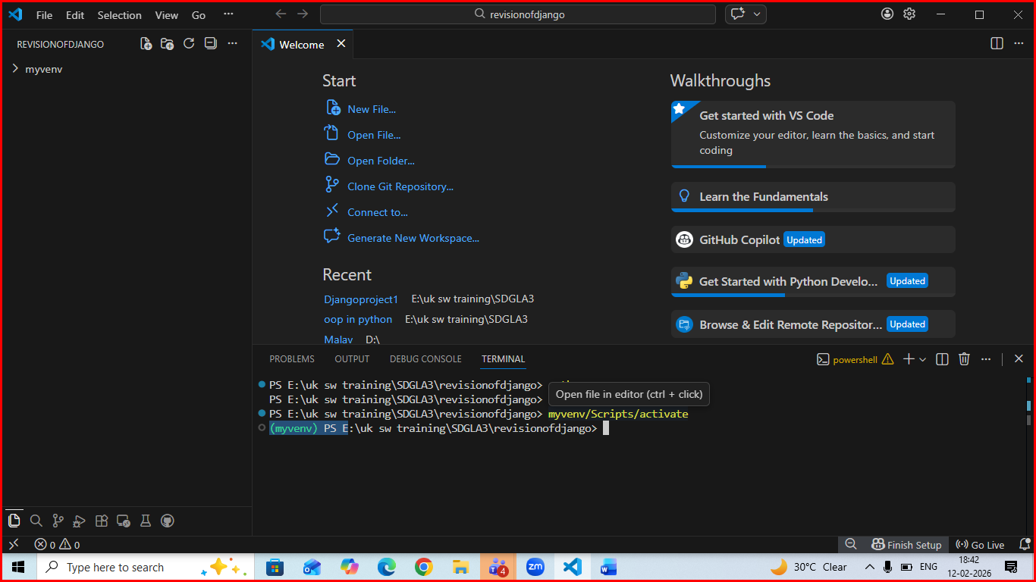
Install Django in virtual env using command : pip install Django like below
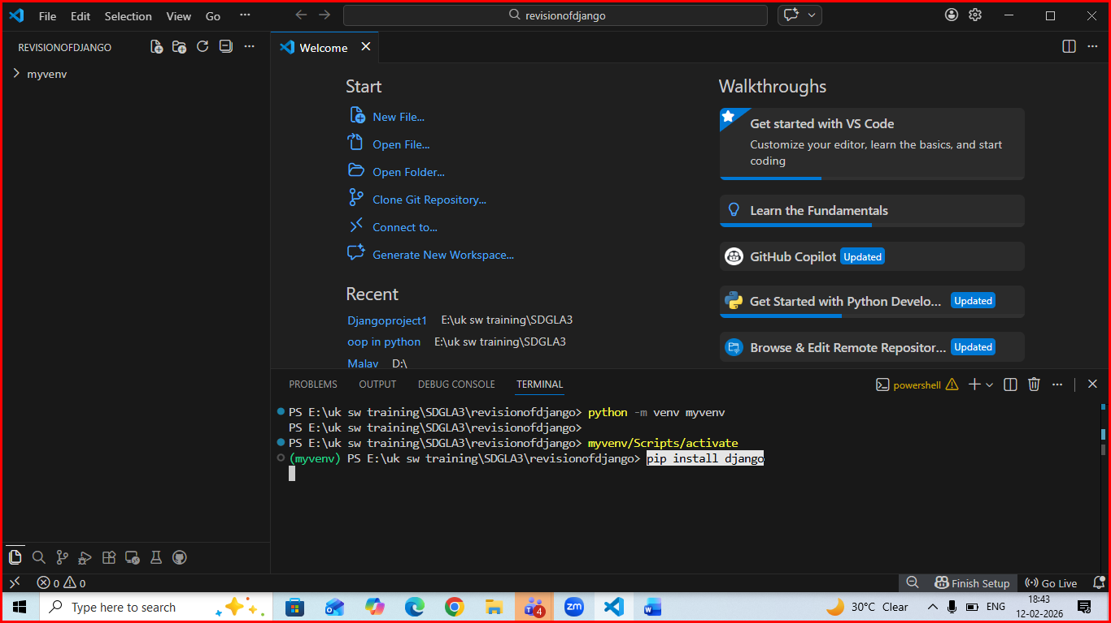
Then create new Django project using command : django-admin startproject demoproject . (don’t forget . after name of project)
Like :
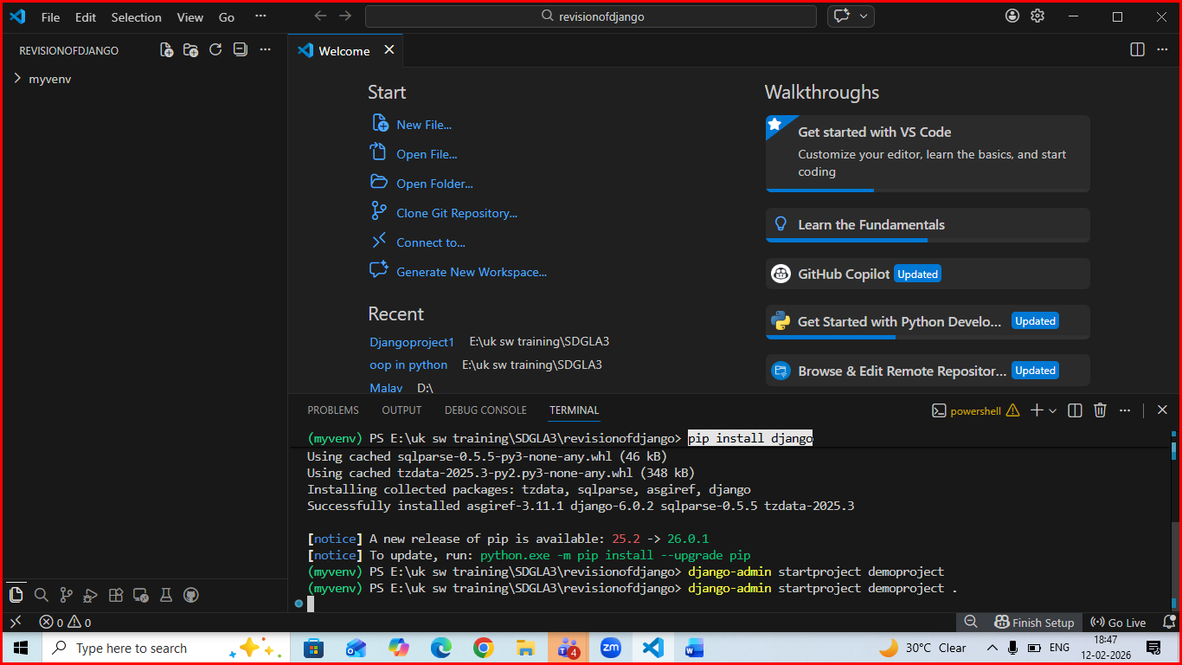
Your project structure should like below : 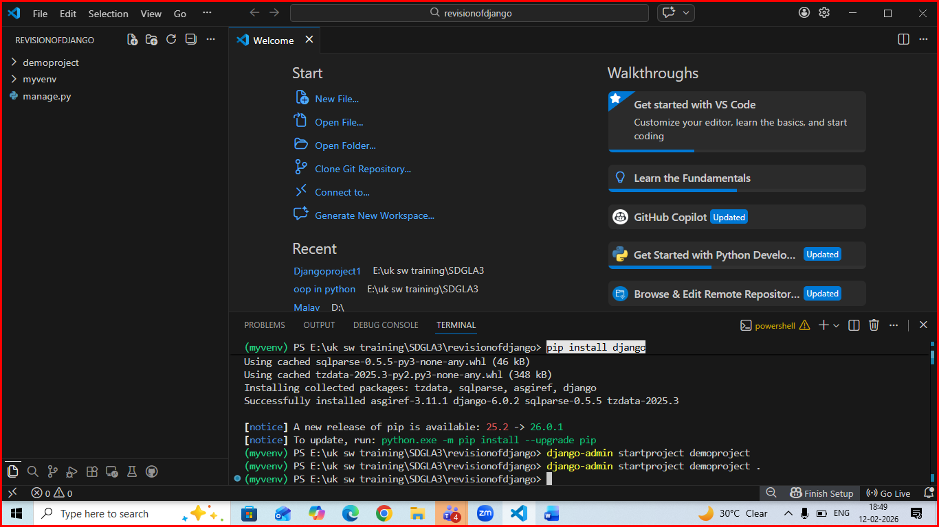
Create new app with command : python manage.py startapp firstapp
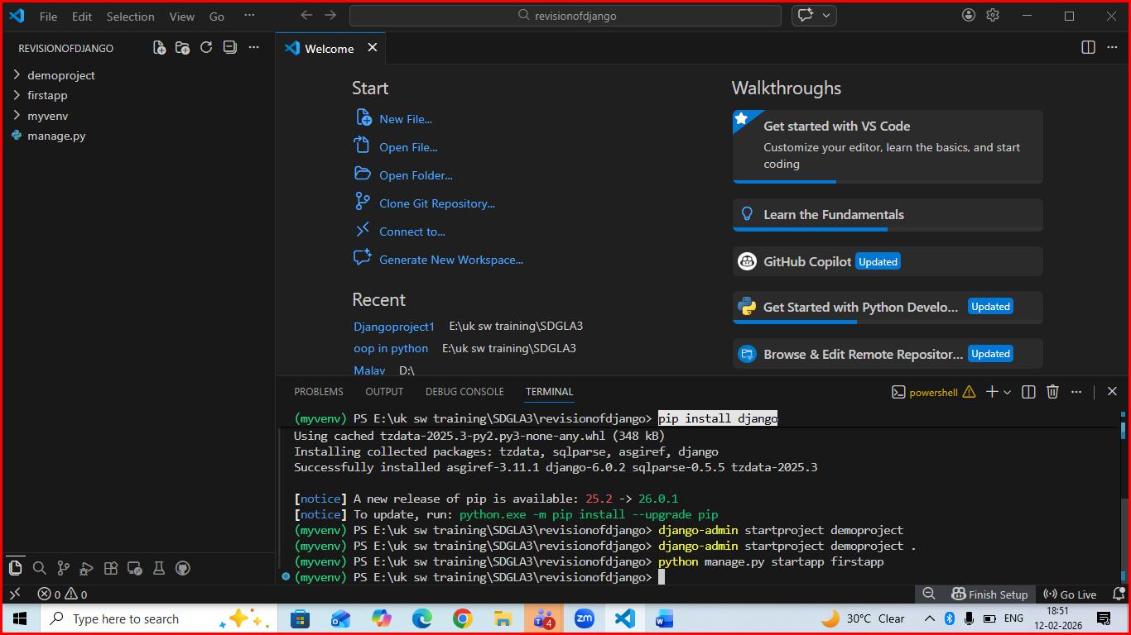
Open setting.py of project and add newly created app in installedapp section :
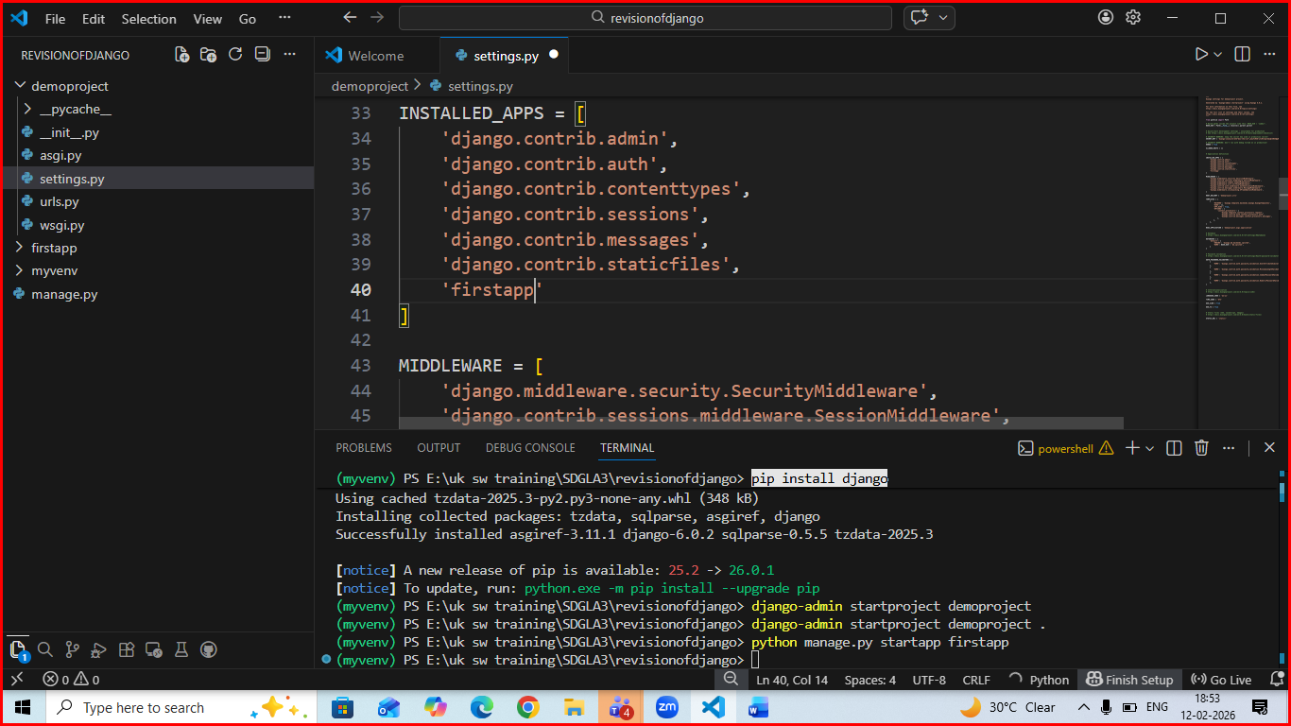
Create a urls.py file in app folder :
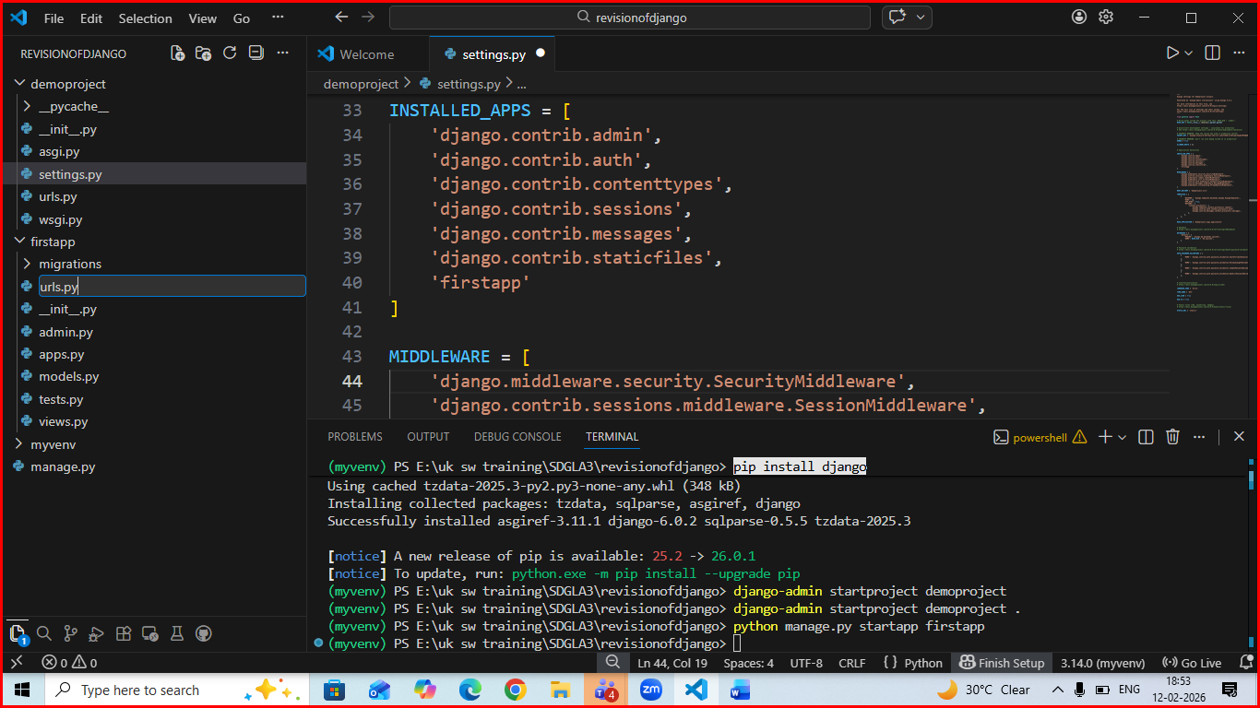

Open view.py and write logic over there and then connect view with urls .py of app then we will use it in urls.py of main project
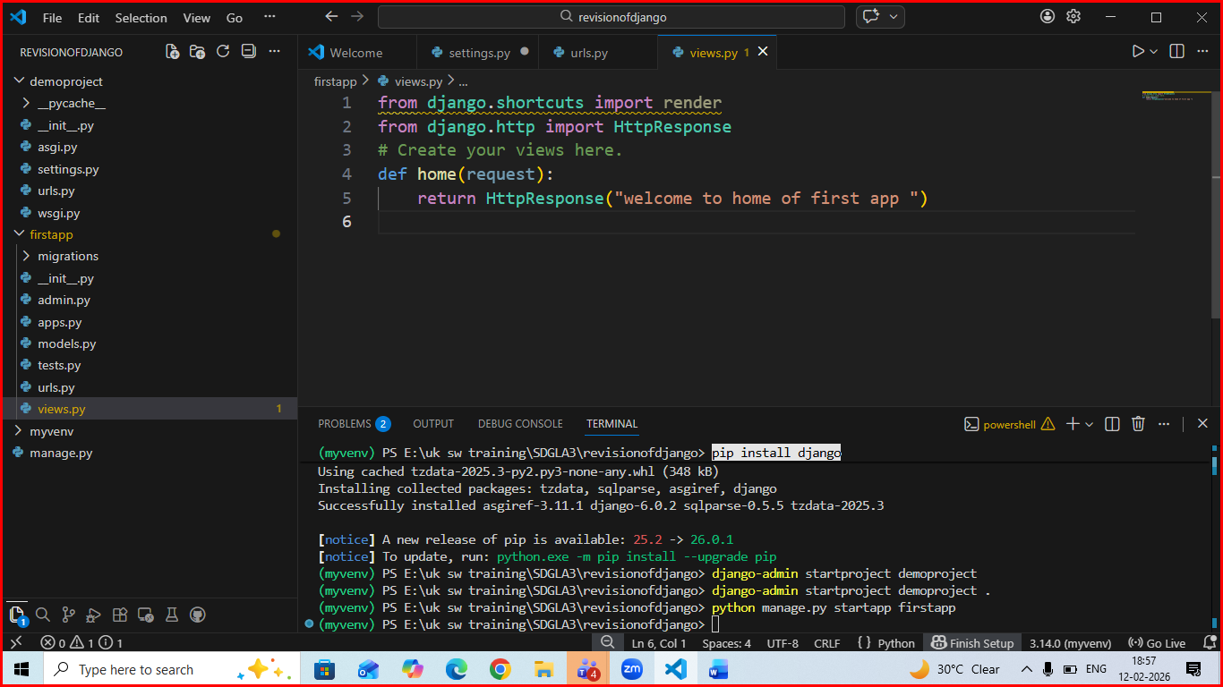
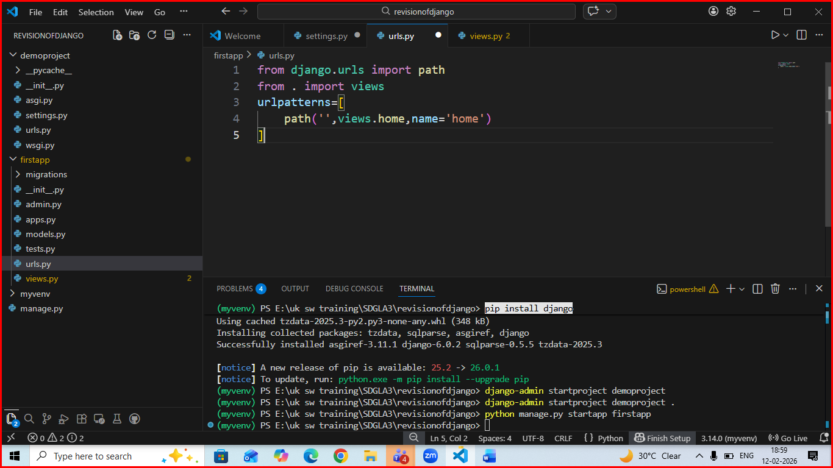
Make changes in urls.py of main project
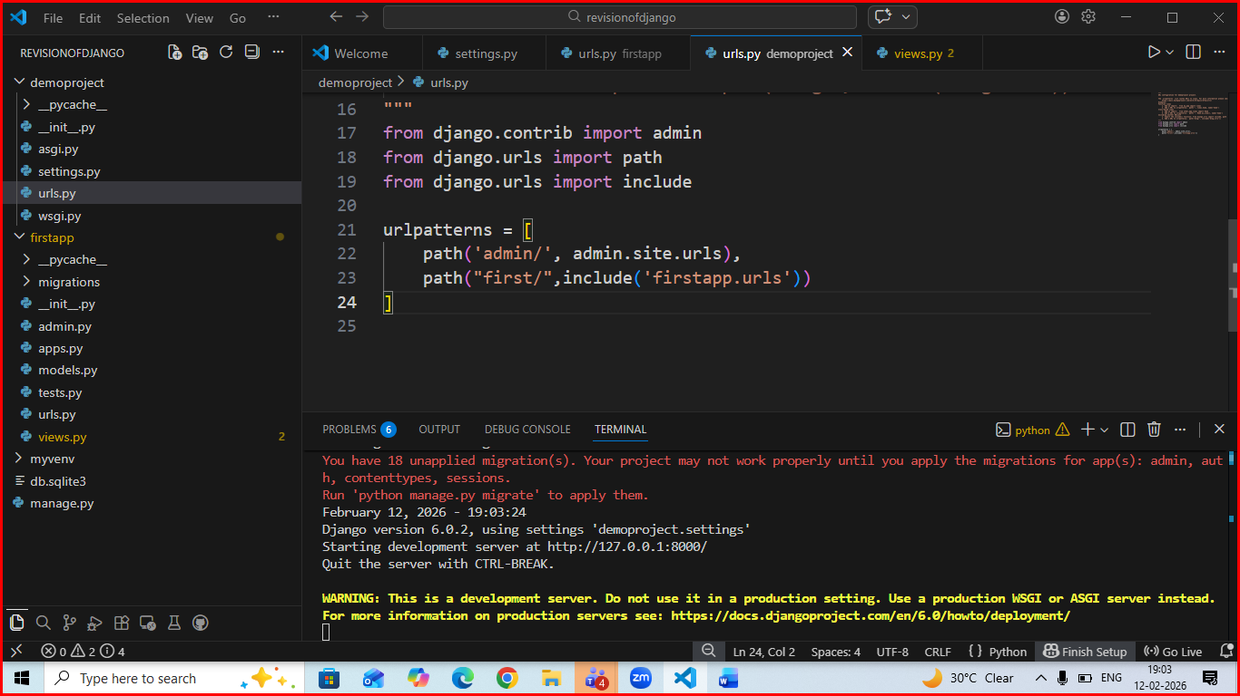
Go to models.py of app and create a new model user lke this
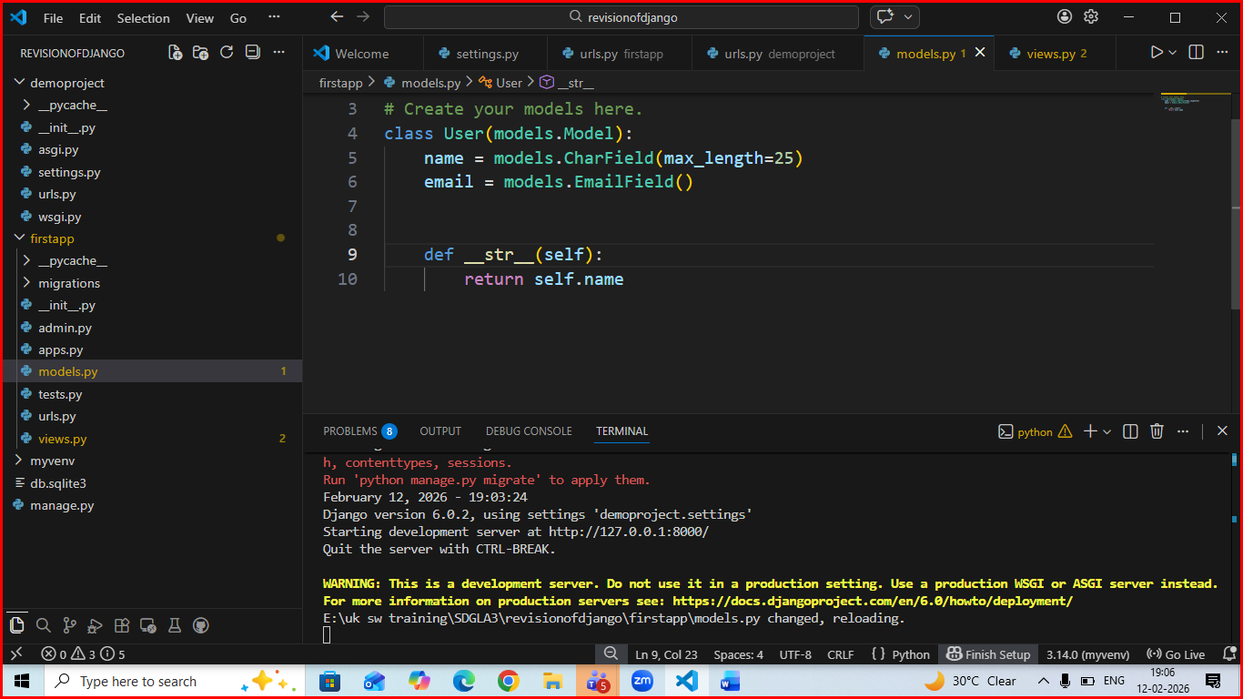
Then run makemigration command and migrate command like below and see changes in database using sqlite extension
Use ctrl+c to stop running server
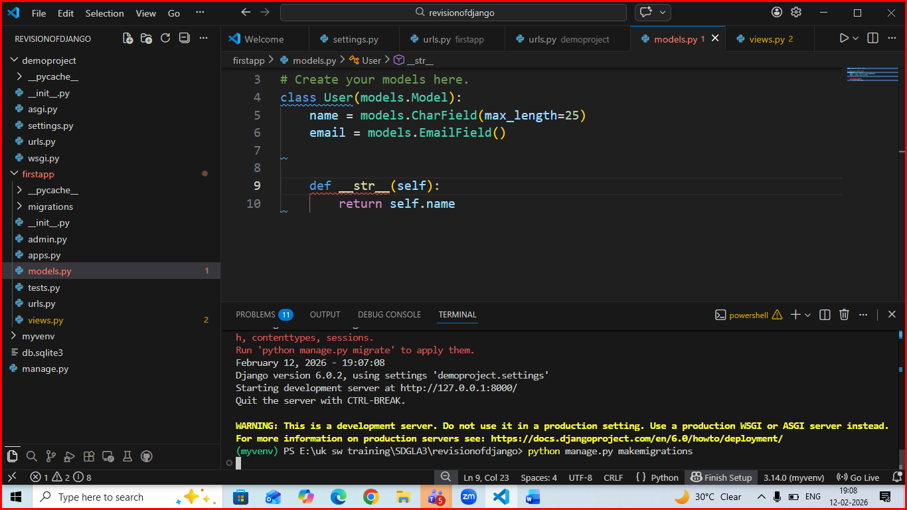
Output after successful of makemigrations:

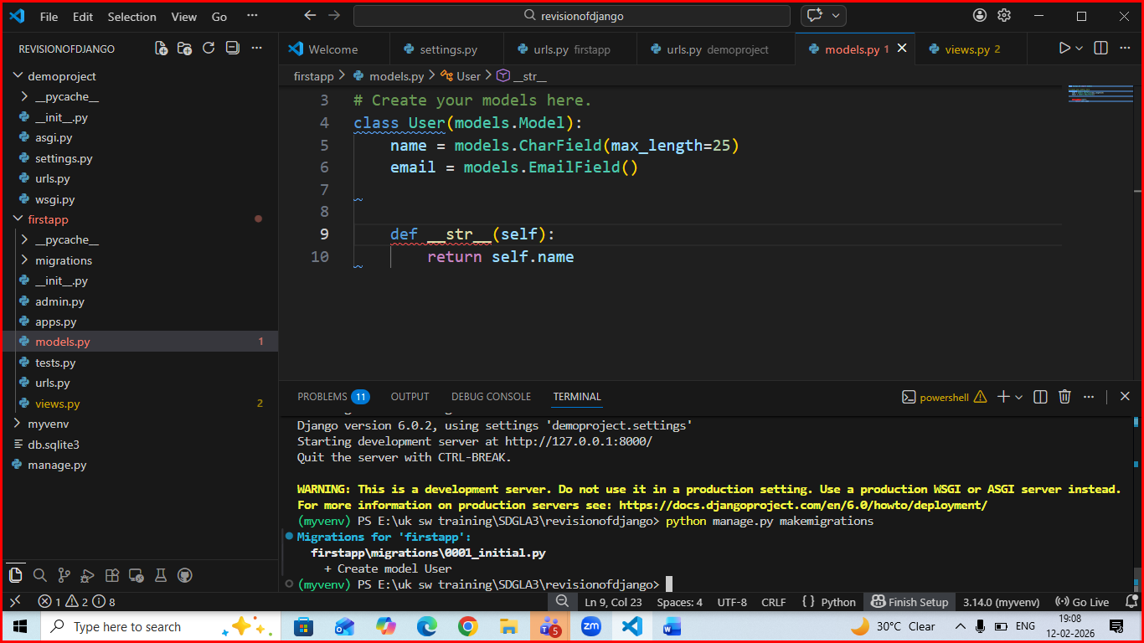
Then run migrate command:
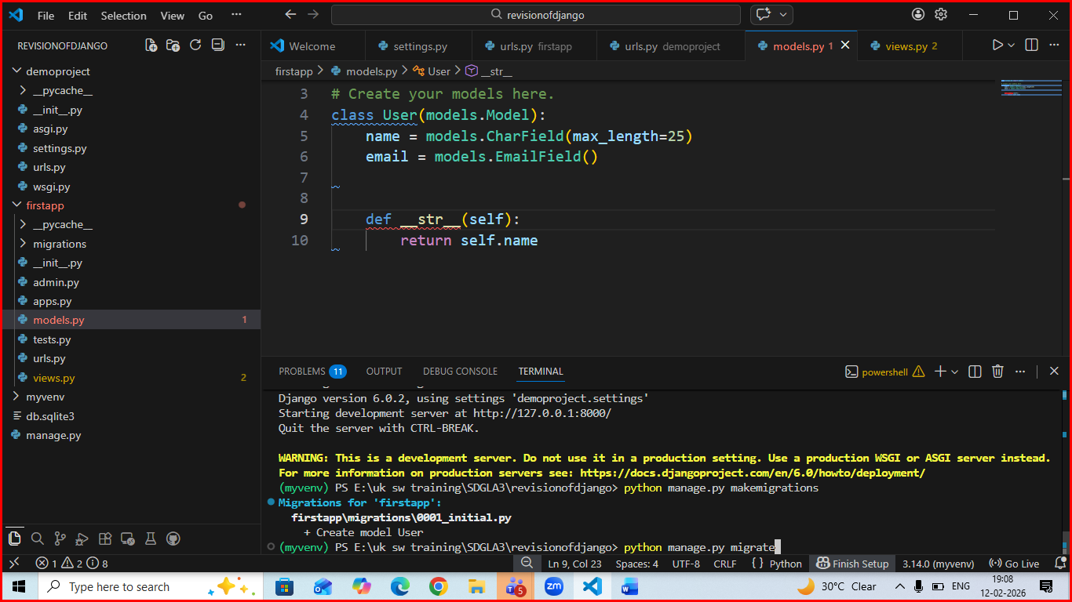 see output of migrate
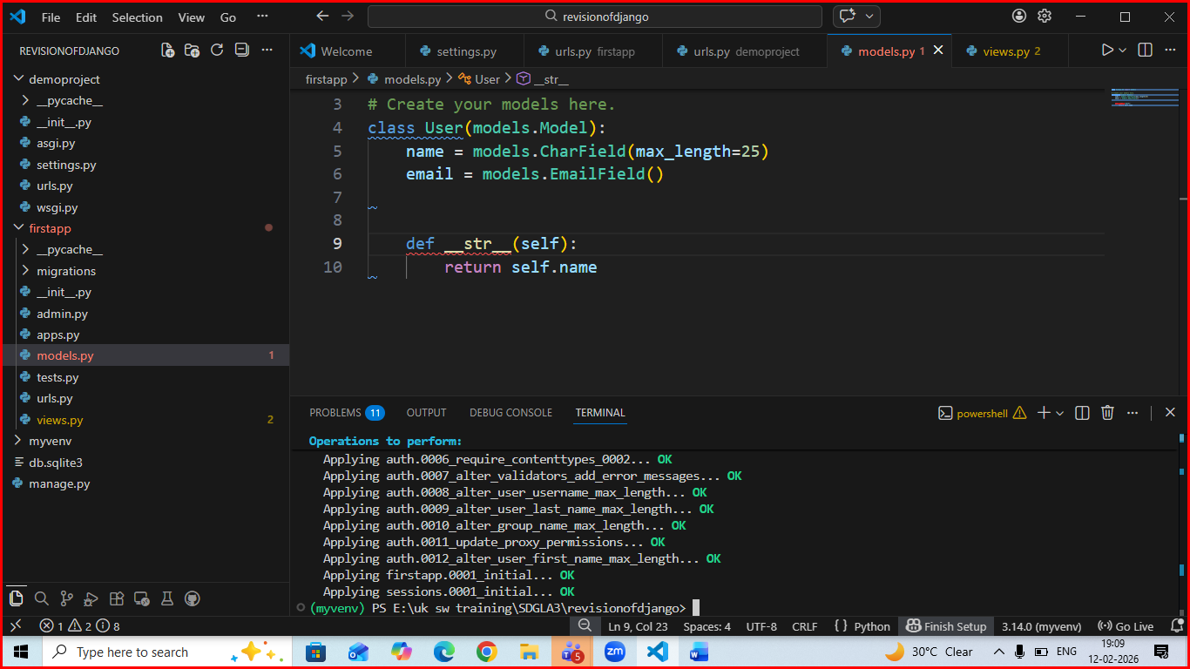
Open db.sqlite3 file using sqlite extension and see tables created by Django
